**Make a website**

**1. HTML-section**

**1. 1. Introduction**

Web pages are created using HTML and CSS. What do these languages do?

* HTML is used to establish a page's structure. It also lets us add text, links and images.
* CSS is used to control the design and layout of the page.

|  |  |
| --- | --- |
| **HTML** | **HTML + CSS.** |
| * [Brand](http://external-production.codecademy.com/assets/secure/index-c5bf1319f62cb07c26239e761a9ed5c9.html) * [Browse](http://external-production.codecademy.com/assets/secure/index-c5bf1319f62cb07c26239e761a9ed5c9.html) * [Sign Up](http://external-production.codecademy.com/assets/secure/index-c5bf1319f62cb07c26239e761a9ed5c9.html) * [Log In](http://external-production.codecademy.com/assets/secure/index-c5bf1319f62cb07c26239e761a9ed5c9.html) * [Help](http://external-production.codecademy.com/assets/secure/index-c5bf1319f62cb07c26239e761a9ed5c9.html)  Find a place to stay. Rent from people in over 34,000 cities and 192 countries. Neighborhood Guides Not sure where to stay? We've created neighborhood guides for cities all around the world.  http://s3.amazonaws.com/codecademy-content/courses/ltp/img/mexico-city.png |  |

### 1.2. HTML elements

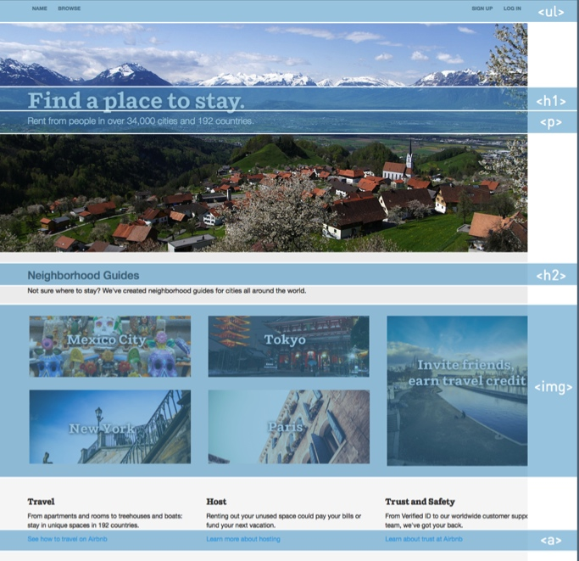HTML elements are the building blocks of web pages.

The web page to the right is made up of a collection of HTML elements. Each element is outlined in blue and labeled with its name.

HTML elements describe each piece of content on a web page so that the web browser knows how to display it.

The next few cards will cover five common HTML elements.

### 1.2.1. Heading elements

Headings are described by heading elements. There are six levels of heading elements: **h1** to **h6**.

The **h1** element is used to describe the main heading of the page.

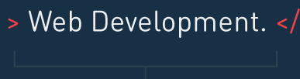

### 1.2.2. <p>

Similar to a news article or a word document, headings in a web page are usually followed by paragraphs.

In HTML, paragraphs are described by paragraph elements, or **p** elements.



### 1.2.3. <a>

The defining feature of the Web is the presence of links. Clicking on links leads to other web pages. The **a** element is used to create links.

The **a** element is similar to the **h1** or **p** elements, but it has two key differences:

* First, it has an href attribute which equals the website you want to link to.
* Second, you get to choose the link text that users see on the page.

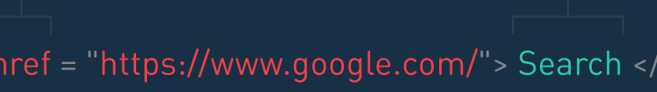

### 1.2.4. <img>

In addition to headings and paragraphs, a web page can have images. The **img** element is used to add images to a page.

The **img** element has an attribute inside the opening<img> tag named src. The src attribute has the address of the image.

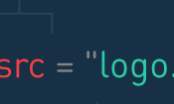

### 1.2.5. <ul> and <li>

In addition to paragraphs and images, content can be presented as lists.

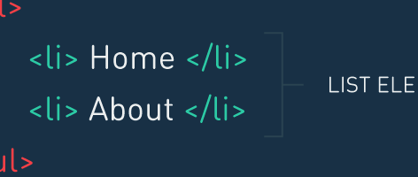In HTML, a bulleted list is described using a **ul**element. Each item in the list is placed inside an **li**element.

### 1.2.6. <html> and <body>

Here's an example of a real web page:

* Everything inside a web page is nested inside the **html** element
* The **body** element contains the actual content of the web page - everything nested inside<body> and </body> shows up in the web browser

The **doctype** at the start of the HTML file tells the browser which version of HTML you are using. The doctype is not an HTML element, so it doesn't have a closing tag. The doctype ensures that your web page displays consistently when its visited from different browsers.

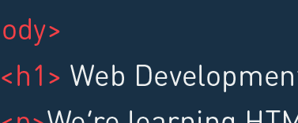

### 1.3. Make a Website: HTML

### 1.3.1. Navigation

We just learned about five HTML elements. Now let's see how to use them together to start creating the Airbnb home page.

Let's start by adding a navigation menu to the page. This can be done by writing a ul element inside thebody element. A ul element describes a bulleted list:

|  |  |
| --- | --- |
| **Code** | **Result** |
| <!DOCTYPE html>  <html>  <body>  <ul>  <li>Item 1</li>  <li>Item 2</li>  <li>Item 3</li>  </ul>  </body>  </html> |  |

Each item in the list is placed inside an li element. Each li is nested inside the <ul>..</ul> tags, as represented by 2 spaces.

### 1.3.2. Wrap with a div

To stay organized, let's wrap the ulelements with two divs, like this:

|  |  |
| --- | --- |
| **Code** | **Result** |
| <!DOCTYPE html>  <html>  <body>  <ul>  <li>Item 1</li>  <li>Browse</li>  </ul>  <ul>  <li> Sign Up</li>  <li> Log In</li>  <li> Help</li>  </ul>  <div class="nav">  <div class:"container">  </div>  </body>  </html> |  |

A div element groups other elements together into sections of the web page, such as a navigation bar, the main body, and the footer.

The outer <div class="nav">..</div> groups the elements into the navigation bar section of the web page. The inner <divclass="container">..</div> wraps the contents in a container. We'll use both classes in the next section to style the navigation bar.

### 1.3.3. Large feature

We've used ul elements to create a minimal navigation bar, and used divs to organize it into its own section.

Next let's add a large feature to the page with an h1 element, and a subtitle using a-& p- element.

|  |  |
| --- | --- |
| **Code** | **Result** |
| <body>  <div class="nav">  <div class="container">  </div>  <h1>Find a place to stay</h1>  <p>Rent from people in over 34,000 cities and 192 countries.</p> |  |

### 1.3.4. Wrap with a div

As before, let's group this large feature with two divs to stay organized, like this:

|  |  |
| --- | --- |
| **Code** | **Result** |
| <div class="jumbotron">  <div class="container">  <h1>Find a place to stay</h1>  <p>Rent from people in over 34,000 cities and 192 countries.</p>  </div> </div> |  |

The outer <divclass="jumbotron">..</div> group the elements into the large feature section of the web page. The inner<div class="container">..</div>tags wrap the contents in a container. We'll use both classes in the next section to style the large feature

### 1.3.5. Supporting content

Below the jumbotron, let's add a piece of supporting content. The piece will have an h3, a p, and an a, like this:

|  |  |
| --- | --- |
| **Code** | **Result** |
| <div>  <h3>Travel</h3>  <p>From apartments and rooms to treehouses and boats: stay in unique spaces in 192 countries.</p>  <p>  <a href "#">See hov to travel on airbnb</a>   </p> </div> |  |

1. The h3 describes the subheading, the p adds a description, and the aprovides a link.
2. All three elements are grouped together using a div to keep things organized.

**2. CSS**

**2.1. Introduction**

Web pages are created using HTML and CSS.

* HTML is used to write a web page's content.
* CSS is used to define the design and layout of the page.

The HTML never changes. The same HTML file is styled three different ways by using three different CSS files. All the visual differences in color, font, and where elements are arranged on the page are a result of CSS.

|  |  |  |
| --- | --- | --- |
|  |  |  |

A web page is a collection of HTML elements. CSS is used to control the appearance of an HTML element.

The code specifies that h1 elements be colored red. This code is called a CSS rule.

|  |  |  |
| --- | --- | --- |
|  |  |  |
| **In CSS** |  | **Website** |

**2.2.CSS Rules**

CSS uses rules to style HTML elements. Here's how CSS rules work:

1. A CSS rule starts with a selector. A selector specifies which HTML elements to style. Here the h1 CSS selector selects all h1 HTML elements on the page.
2. Inside the braces { }, a property and its valuedefine what aspect of the h1 elements to style. Setting the color property to red changes the color of the h1 element to red.

Together, a selector and its property-value pairs are called a CSS rule.

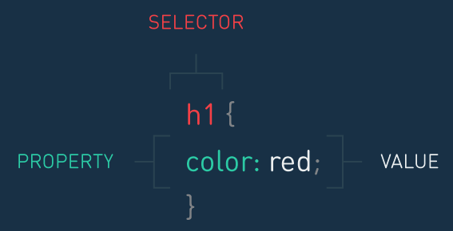

### 2.2.1. Class Attribute

HTML elements can be CSS selectors, but they're not the only selectors available. Another available selector is the class selector.

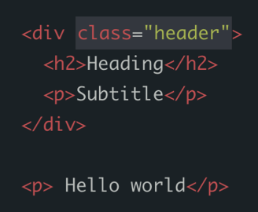To see how it works, let's first look at the HTML to the right. HTML elements can carry a classattribute.

### 2.2.2. Class Selector

The class can be targeted from CSS by using a dot (.), as seen in the CSS to the right.

|  |  |  |
| --- | --- | --- |
|  |  |  |
| **In CSS** |  | **Website** |

The .header selector applies a blue text color only to the elements nested inside<div class="header">..</div>.

In this way, classes are useful to specifically target groups of HTML elements.

### 2.2.3. Combining Selectors

It's possible to be even more specific by combining classes and element names.

|  |  |  |
| --- | --- | --- |
|  |  |  |
| **In CSS** |  | **Website** |

This CSS selector selects any p element nested inside an HTML element with the class namedheader, and colors it blue.

In this way, a CSS rule targets specific HTML elements on the page and applies a style to them.

The next few cards will cover three common CSS properties available to style HTML elements.

**2.3.Text**

**2.3.1. Color**

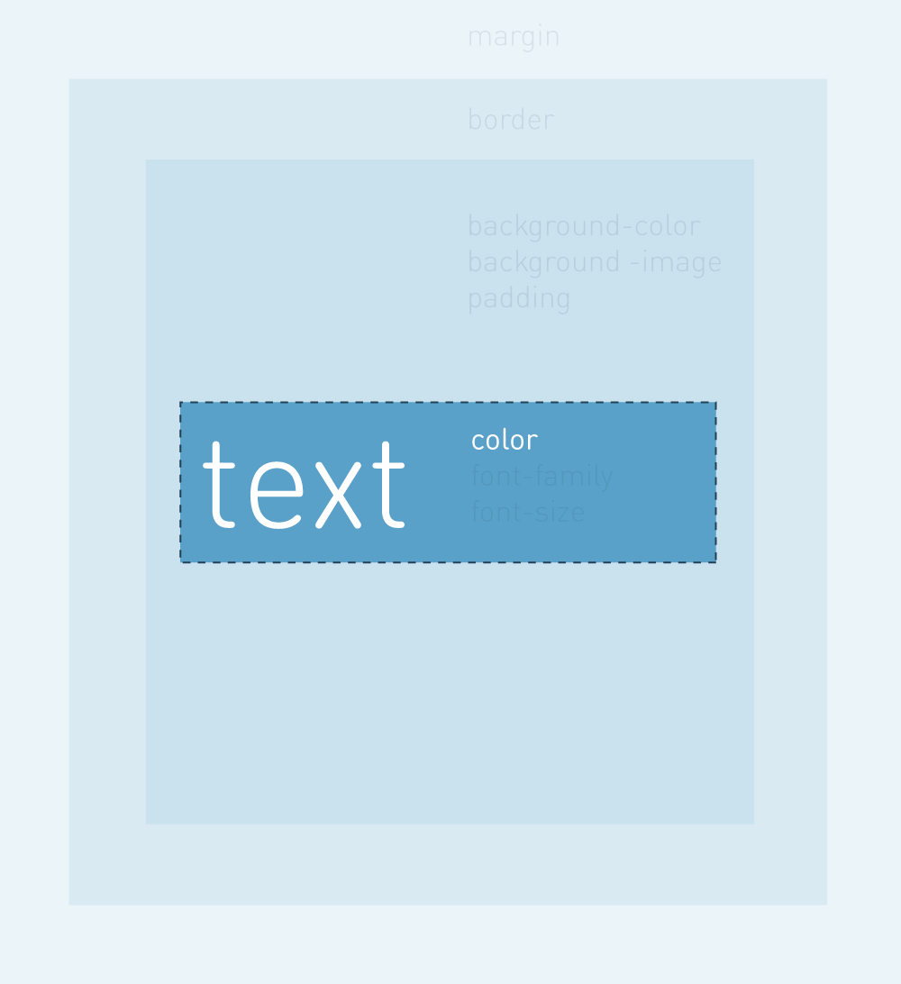The color property sets the color of an HTML element's text.

We can use color names to change the text's color. But this only works for [140 colors](http://www.crockford.com/wrrrld/color.html" \t "_blank).

Instead, we can use RGB values or hexadecimal numbers. They can represent millions of colors. RGB values and hex numbers express colors as different amounts of red, green and blue.

* RGB values range from 0 to 255, with 255being the brightest.
* Hex numbers vary from 00 to ff, with ffbeing the brightest.

**2.3.2. Font-family**

The font-family property sets the font of an HTML element's text. Three fonts commonly used with font-family are:

font-family: Arial, Helvetica, sans-serif;

font-family: "Times New Roman", Times, serif;

font-family: "Courier New", Courier, monospace;

**[Google Fonts](http://www.google.com/fonts" \t "_blank)** is a free collection of over 600 more web fonts that you can use on your page.

**2.3.3. font-size**

The font-size property sets the size of an HTML element's text.

Text size can be measured in pixels, ems, or rems. We will use pixels here.

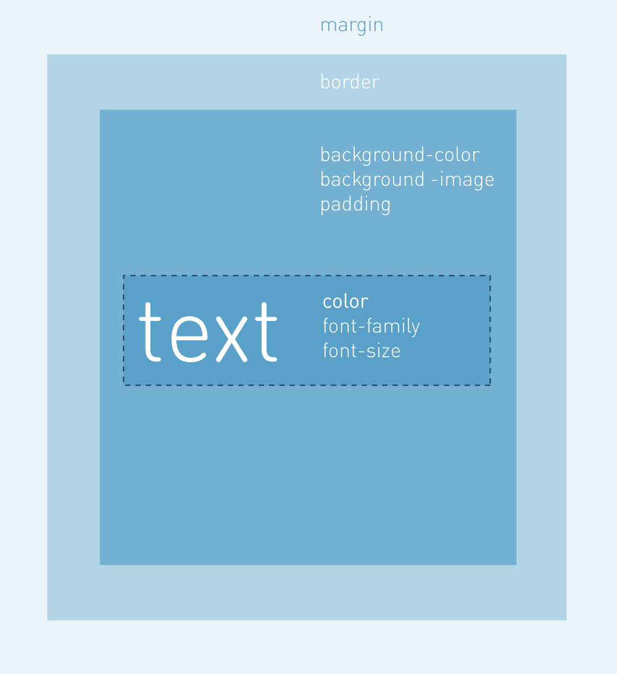**2.4. Review**

CSS uses rules to define the design of an HTML element.

Here's an HTML element labeled with the CSS properties that control different aspects of its appearance. When you want to style an HTML element, imagine there is a box around it and apply these properties to style it.

We've already looked at three properties to control the appearance of an HTML element's text. The next few cards will cover five more properties that affect the space surrounding the text.

**2.4.1. Background-color**

The background-color property sets the color for the background of an HTML- element.

**2.4.2. Background-image**

Instead of a solid color, the background-imageproperty sets an image as the background of an HTML element.

**2.4.3. Border**

The border property sets the width, style, and color of an element's border

**2.4.4. Padding**

The padding property creates space between the content and border of an element. This whitespace is useful in order to improve readability and organization of the page.

The padding property sets the the padding on all sides. It's possible to set the padding on each side. The properties padding-top, padding-bottom,padding-left, and padding-right are available to set the padding on each side of an HTML element.

**2.4.5. Margin**

The margin property creates space for multiple HTML elements. The margin is a transparent area outside the border of an element.

The margin property sets the margin on all sides. It's possible to set the margin on each side. The properties margin-top, margin-bottom,margin-left, and margin-right are available to set the margin on each side of an HTML element.

The properties margin-left, and margin-rightare available to set the margin on either side of an HTML element. If one of these properties is set toauto, then it will take as much as possible. To move the HTML element to the far left of the screen, use margin-right: auto. This will maximize the amount of space there is on the right side margin, pushing the element to the far left. To center an element, set margin-right: auto andmargin-left: auto. The margin to the left and right will be equal and the element will be centered.

**2.5. <head> and <link>**

Here's an example of using CSS in a web page:

The head element contains information that the web browser needs to display the page.

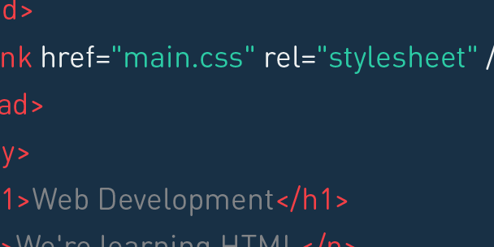The link element tells the browser where to find the CSS file used to style the page. The relattribute tells the browser that the file being linked is a CSS file to style the page. The hrefattribute gives the browser the path to the CSS file.

The body element contains the content of the page that shows up in the web browser.

### 2.6. Make a Website: CSS styling

We just saw eight CSS properties and how they can be used to style HTML elements. Now let's use them together to start styling the Airbnb home page.

The file main.css has the CSS rules that styles the HTML in index.html. We'll create these CSS rules in this section.

**2.6.1. Navigation**

Let's start by styling the navigation bar.

In index.html, the <divclass="nav">..</div> groups elements that are part of the navigation bar section of the web page. Inside <div class="nav">..</div> are the a elements we want to style.

Therefore, we can select all aelements inside <divclass="nav">..</div> in CSS like this:

|  |  |
| --- | --- |
| **Code in CSS** | **Result** |
| .nav a {  color: #5a5a5a;  font-size: 11px;  font-weight: bold;  padding-top: 14px;  padding-right: 10px;  padding-bottom: 14px;  padding-left: 10px;  text-transform: uppercase;  } |  |

**2.6.2. Jumbotron**

The links in the navigation bar are styled. Next, let's style the large feature section. In index.html, the <divclass="jumbotron">..</div> groups elements that are part of the large feature section.

|  |  |
| --- | --- |
| **Code in CSS** | **Result** |
| .jumbotron {  height:500px;  background-image:url('http://goo.gl/04j7Nn');  } |  |

**2.6.3. Jumbotron: Heading**

The large feature section now has a background image, and the web page is starting to come together. However this dark background image makes the heading and paragraph text difficult to see. Let's fix that with CSS, starting with the h1 element. In index.html, the <divclass="jumbotron">..</div> groups elements that are part of the large feature section of the web page.

Inside <div class="jumbotron">..</div> is the h1 element we want to style.

Therefore, we can select all h1elements inside <divclass="jumbotron">..</div> in CSS like this:

|  |  |
| --- | --- |
| **Code in CSS** | **Result** |
| .jumbotron h1{  color: #fff;  font-size: 48px;  font-weight: bold;  } |  |

**2.6.4. Jumbotron: Paragraph**

Now that we can see theh1 element text, let's style the pelement so that we can see its text too.

|  |  |
| --- | --- |
| **Code in CSS** | **Result** |
| .jumbotron p{  color:#fff;  font-size: 20px;  } |  |

**2.6.5. Jumbotron: Fonts**

The text inside the large feature section stands out. Let's make the h1 text stand out more by changing its font. Custom fonts can be loaded from CSS, like this:

|  |
| --- |
| <!DOCTYPE html> <html>  <head>  <link href="font.css" rel="stylesheet">  <link href="main.css" rel="stylesheet">  </head>  </html> |

Inside the head element are two linkelements. The order of these linkelements matters.

1. The browser first sees the link for the custom font font.css, and makes the font available to use in the page.

2. Next the browser sees the linkfor main.css. Since the browser now knows about the custom font, we can use it from main.css to style elements.

**3. Organise your page**

**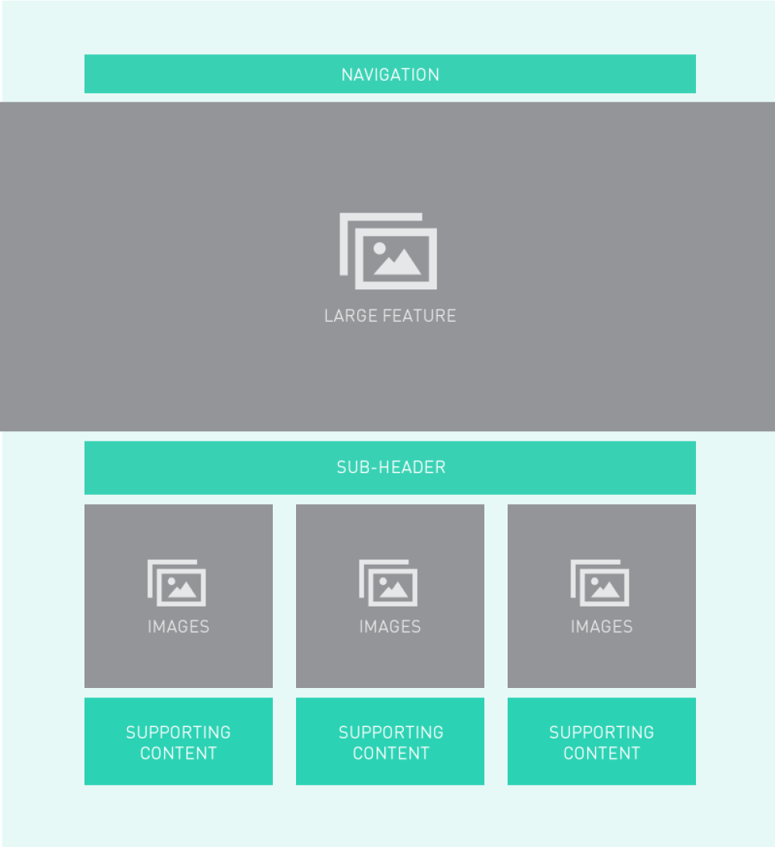3.1. Introduction**

A web page is a collection of HTML elements. CSS can control the design of an element, like its color, font, and spacing. CSS can also control where an element sits on a page to create a page layout.

For example, the layout to the right has a top navigation bar, a large feature element, a grid of images, and then three pieces of supporting content. What CSS properties are available to move elements around and create page layouts? Here are three common CSS properties.

**3.2. Display**

CSS treats HTML elements like boxes. A box can be "block" or "inline". Block elements display on a new line (e.g., h1,p, ul, li). Inline elements display on the same line as their neighboring elements (e.g., img, a) It's possible to change whether a box is block or inline by using the display property.

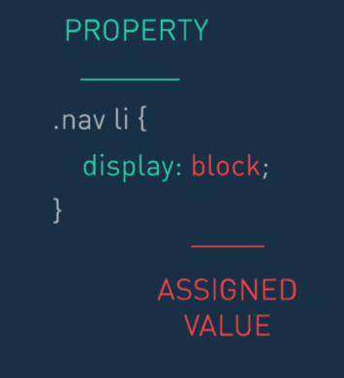

**3.3. Position**

The position property is used to move an HTML element to a precise position on the page.

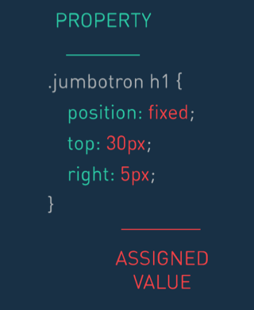By setting position: relative, you can use the CSS properties top, left, bottom, and right to shift an element away from where it would have normally appeared on the page.

**3.4. Float**

The float property moves an element to the far left or far right of the page.

For example, setting float: right pulls an element to the far right side of the page, and the surrounding text wraps around it.

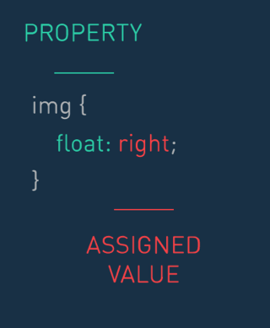

### 3.5. Make a Website: CSS layout.

The CSS properties display,position, and float can be used to control where an element sits on the page. Let's see how to use them to arrange elements on the Airbnb home page.

**3.5.1. Navigation**

The navigation menus are made up of two ul elements. In each ul, the lielements display on new lines because they are block elements. Let's style the li elements so that they display on the same line. This can be done with the displayproperty.

|  |  |
| --- | --- |
| **Code in CSS** | **Result** |
| .nav li{  display: inline;  } |  |

**3.5.2. Jumbotron**

The menu items inside each ulnow are now inline elements. [We'll see how to move the two uls to display on the same line in the next section.]

Next let's change the position of the text inside the large feature. Currently the text is positioned at the very top of the large feature. Let's move the text down so that its more in the middle of the large feature. This can be done with the positionproperty.

In index.html, the <divclass="jumbotron">..</div> groups elements that are part of the large feature section of the web page.

Inside <div class="jumbotron">..</div> is the <divclass="container">..</div> which has the text we want to style.

Therefore, we can select the <divclass="container">..</div> inside<div class="jumbotron">..</div>in CSS like this:

|  |  |
| --- | --- |
| **Code in CSS** | **Result** |
| .container{  position: relative;  top: 100px;  } |  |

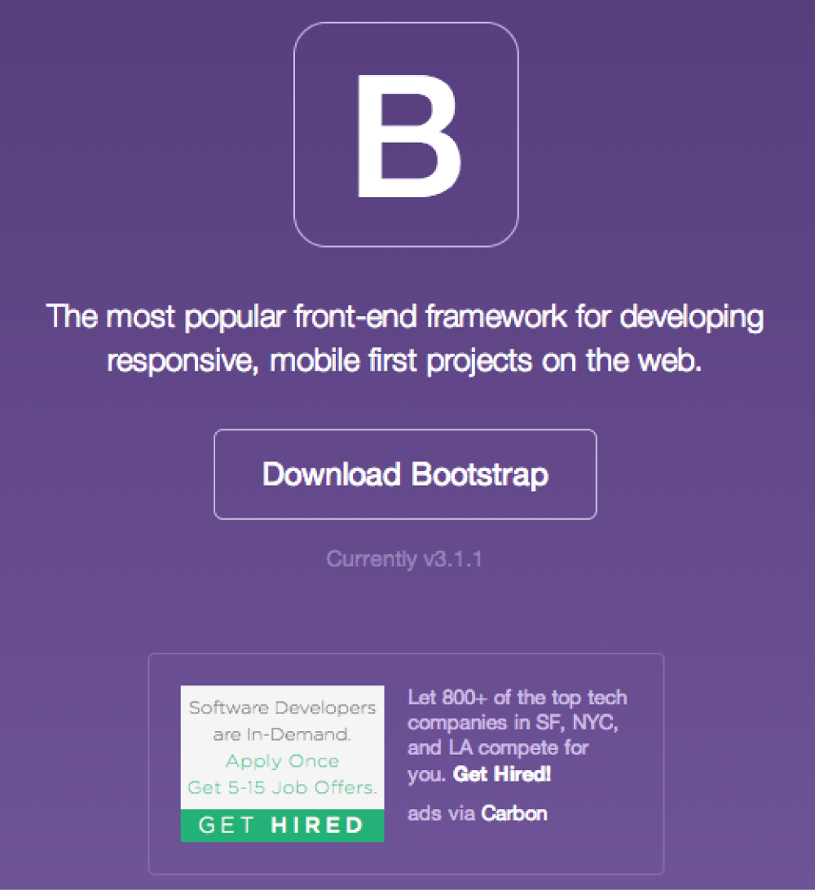**4. Bootstrap**

We saw how to use CSS rules to control the style and layout of a page.

[Bootstrap](http://getbootstrap.com/" \t "_blank) is a collection of prewritten CSS rules used to build web pages faster. Bootstrap provides styles out of the box for several common components on a web page, such as grid layouts, navigation, showcases, and much more.

Let's see how to get started using Bootstrap in your web page.

**4.1. The grid**

A grid is a useful way to create page layouts. Rather than create layouts from scratch, HTML elements can be aligned to a grid in different ways to create custom layouts.

Bootstrap comes with a grid that is made up of 12 equal-sized columns. HTML elements are arranged to span different numbers of columns in order to create custom page layouts.

|  |  |  |
| --- | --- | --- |
|  |  |  |
| **GRID** | **GRID + LAYOUT** | **GRID + LAYOUT + PAGE ELEMENTS** |

**4.2. Page layout**

Bootstrap's grid is made up of 12 equal-sized columns. Each piece of content is aligned to this grid by specifying the number of columns to span.

The code to the right uses Bootstrap's grid to create a layout with two pieces of content.

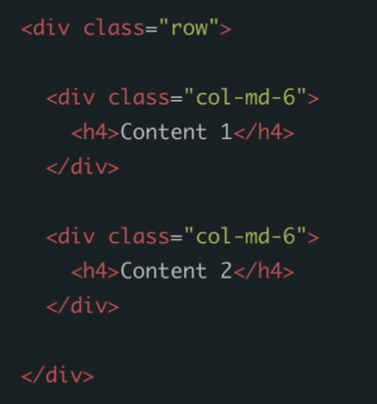

- Here each piece of content spans six columns, so it uses the .col-md-6 class.

- Both columns are wrapped in a .row class to create a horizontal group.

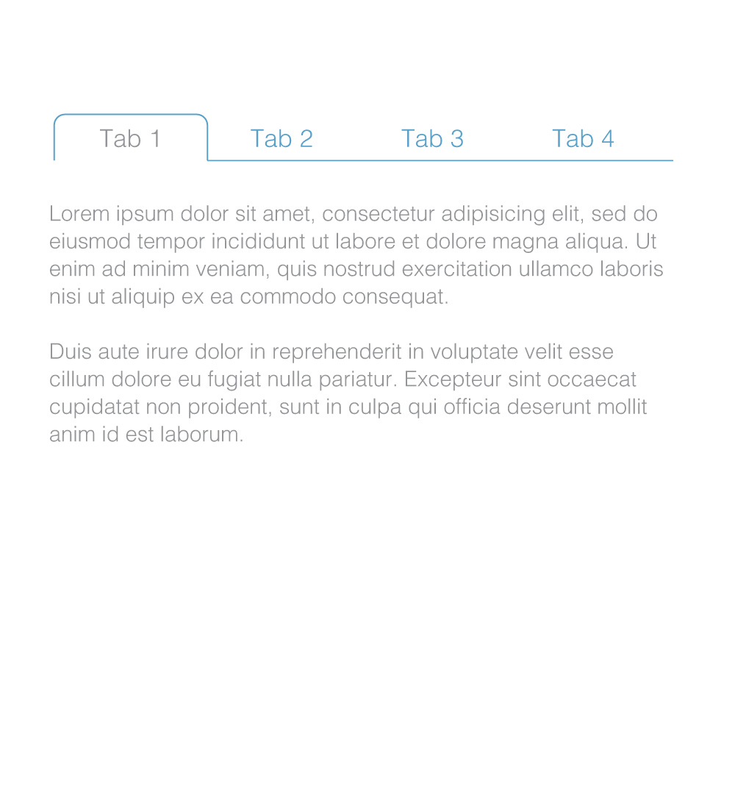**4.3. Tabs**

Tabs are a common navigation technique that give links to different parts of a site. Tabs are seen in sites like [Gmail](https://support.google.com/mail/answer/3055016?hl=en" \t "_blank) and [Codecademy](http://www.codecademy.com/courses/web-beginner-en-bay3D/2/4?curriculum_id=50a3fad8c7a770b5fd0007a1" \t "_blank).

Bootstrap makes it easy to create tabbed navigation. Let's see how to do this.

**4.4. Pills**

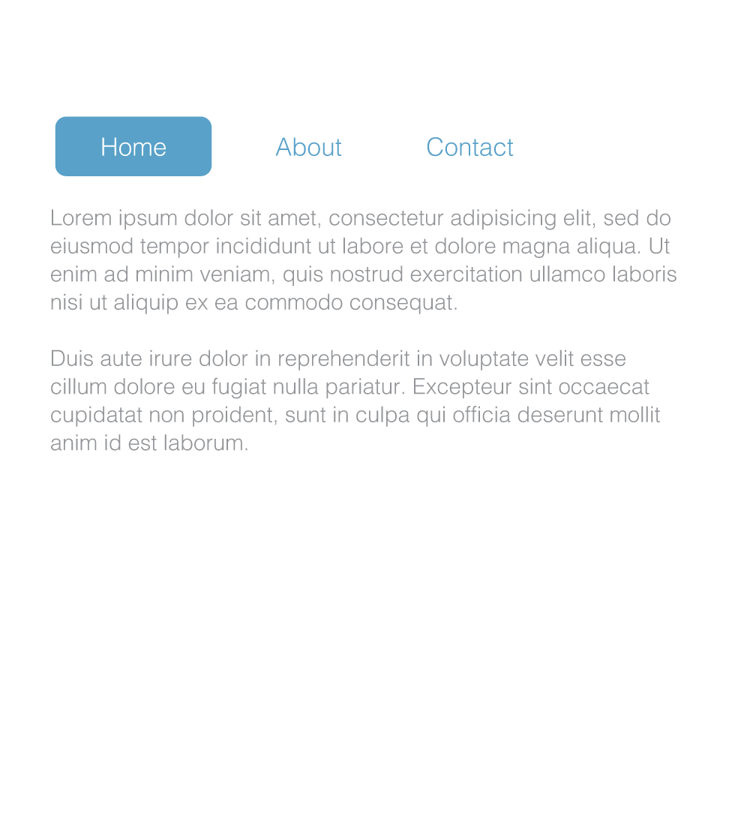Pills are a set of buttons that give links to different parts of a site. Pills are seen in sites like Google's search results page.

Bootstrap makes it easy to create pill navigation. Let's see how to do this.

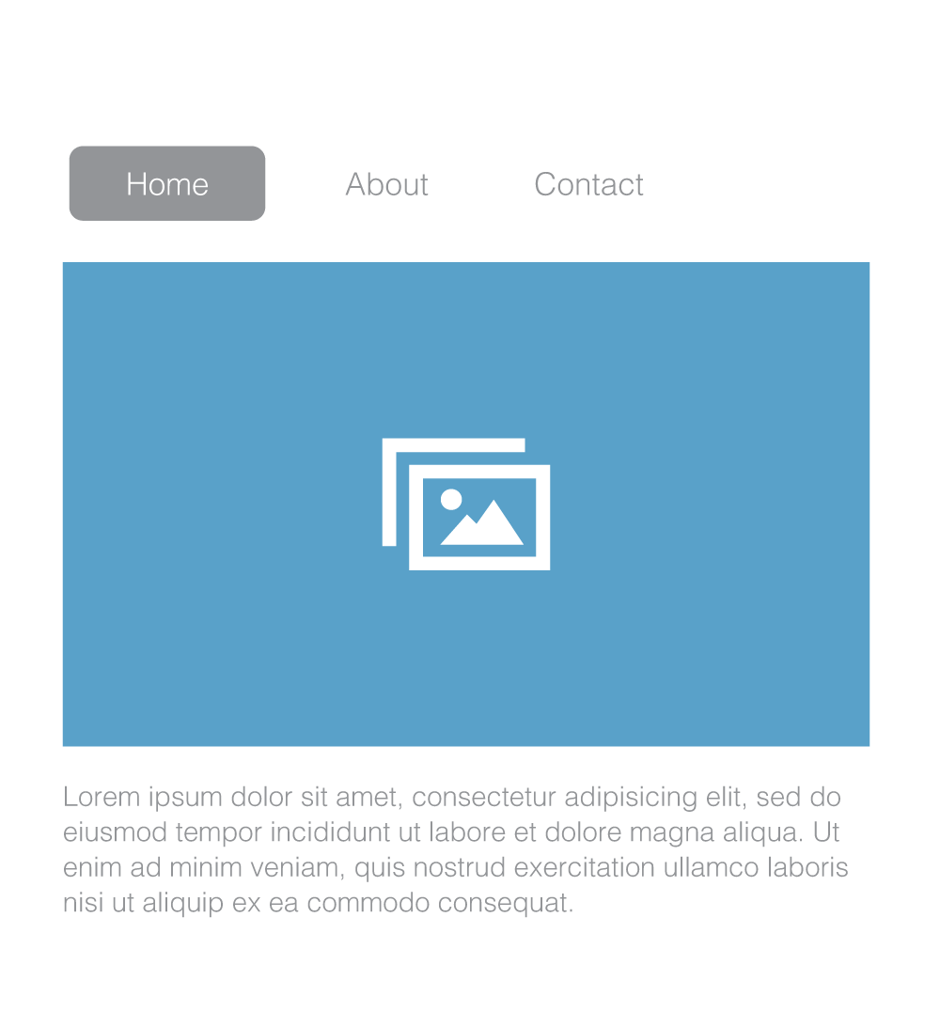**4.5. Jumbotron**

Many sites have a large showcase area featuring important content. Showcases are seen on sites like [Google Mobile](http://www.google.com/mobile/" \t "_blank) and [Apple](http://www.apple.com/ios/" \t "_blank).

Bootstrap calls this large showcase a jumbotron. A jumbotron is used to call extra attention to important content on the site. Let's see how to use it.

**4.6. Summary**

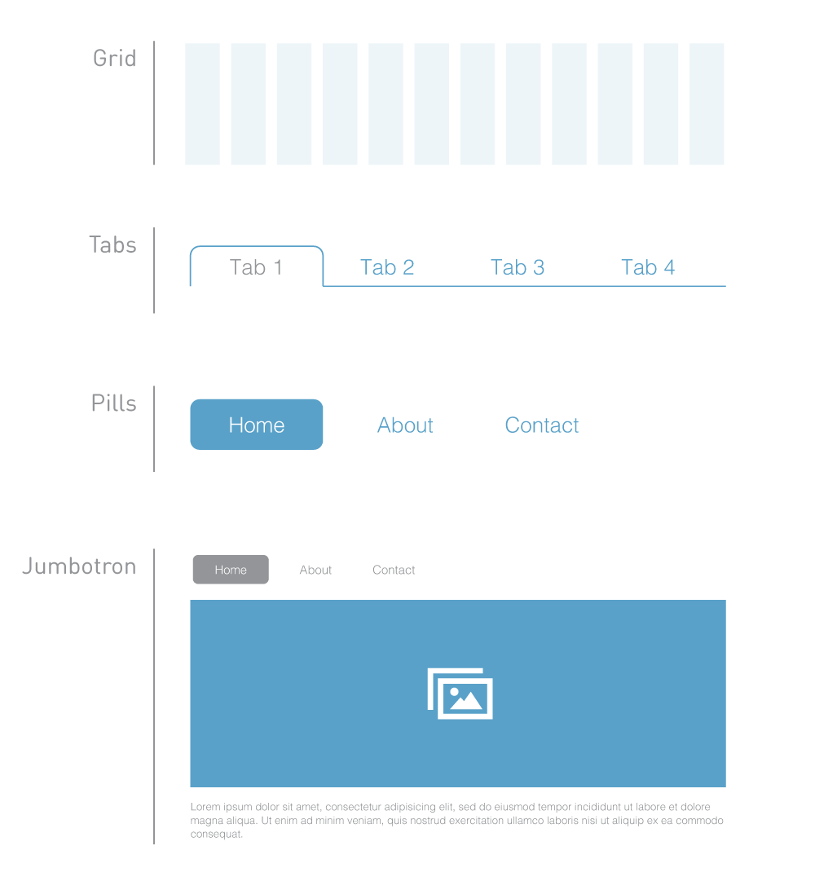By adding Bootstrap classes to your HTML elements, you can make use of Bootstrap's CSS to build your page faster. This lets you quickly set up the basic styles and layout so that you can get to the more interesting aspects of your page's design.

Bootstrap provides CSS for many more web components. Check out [this site](http://getbootstrap.com/css/" \t "_blank) to see how else you can use Bootstrap to style your HTML elements!

### 4.7. Make a Website: Bootstrap

**4.7.1. Adding Bootstrap**

Bootstrap is a CSS framework used to build pages faster. Bootstrap provides a lot of useful CSS out of the box. Check out the Bootstrap file at "<http://s3.amazonaws.com/codecademy-content/courses/ltp/css/bootstrap.css>" - it has CSS properties and values, many of which you've seen already, to style HTML.

To use Bootstrap in a web page, you need to link to it from index.html.

|  |  |
| --- | --- |
| **Code** | **Result** |
| <head>  <link href="http://s3.amazonaws.com/ codecademy-content/ courses/ltp/css/shift.css" rel="stylesheet">  <link rel="stylesheet" href="http://s3.amazonaws.com/codecademy-content/courses/ltp/css/bootstrap.css">  <link rel="stylesheet" href="main.css" > </head> |  |

The order of the CSS files matter.  
1. The browser first sees shift.css, and makes the Shift font available to use in the page  
2. Next the browser seesbootstrap.css, and applies those styles to the page.  
3. Then the browser sees main.css, and applies those custom styles to the page. The custom styles override the Bootstrap styles.

The order of the CSS files tell the browser that your styles in main.cssare more important than the styles inbootstrap.css, so the final page that loads is the customized web page.

**4.7.2. Navigation**

In index.html inside <divclass="nav">..</div>, the navigation menus are made up of two ul elements. So far we've styled the li elements to display on the same line. Now let's style the ulelements to show up on the same line too.

Bootstrap provides the .pull-leftclass to left-align an element, and the.pull-right class to right-align an element. Let's use these classes to finish styling the navigation bar.

|  |  |
| --- | --- |
| **Code** | **Result** |
| <ul class="pull-left">  <li><a href="#">Name</a></li>  <li><a href="#">Browse</a></li>  </ul>  <ul class="pull-right">  <li><a href="#">Sign Up</a></li>  <li><a href="#">Log In</a></li>  <li><a href="#">Help</a></li>  </ul> |  |

**4.7.3. Grid**

Both menus now show up on the same line, and the navigation bar is complete.

Next, let's use Bootstrap's grid to arrange the three pieces of supporting content inside the <divclass="learn-more">..</div>section. Here's how to use Bootstrap's grid.

1. First inside <divclass="container">..</div>, there is a row defined by <divclass="row">..</div>

2. A row is made up of columns, so inside <div class="row">..</div>, there are three columns each defined by <div class="col-md-4">

Why is the .col-md-4 class being used? Remember that Bootstrap's grid is 12 columns. Therefore, to create three equal-sized columns, they each need to span 4 grid columns.

Using Bootstrap's grid, you arranged the three pieces of supporting content into a three-column layout.

Let's use Bootstrap's grid again to create another section on the page. This section will contain a grid of images.

**4.7.4. Images**

Next let's add some images inside the columns.

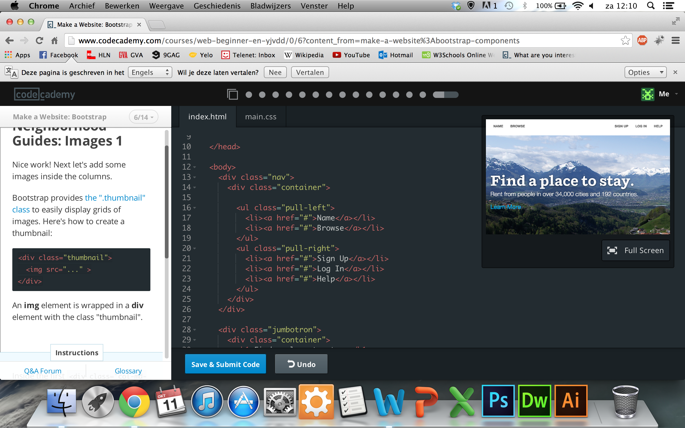Bootstrap provides [the ".thumbnail" class](http://getbootstrap.com/components/#thumbnails) to easily display grids of images. Here's how to create a thumbnail:

An img element is wrapped in a divelement with the class "thumbnail".